

E-info Update Spring 2004

Contents

- Director's Remarks
- News from the Centre
- News from The Health Communication Unit
- News from the International Health Promotion Unit
- Health Promotion Summer School 2004
- Update on the Centre’s Special Projects
- Join the Centre for Health Promotion

Director’s Remarks

It is so great to see the new shoots starting to grow and feel a hint of warmth in the air! As usual, the Centre has been very busy in the past few months. Please check out our revamped website if you haven’t already. Thanks to Nora Sellers for her hard work. It will be easier to maintain and update, but we want to know whether you find it easier to use. New faces at the Centre for Health Promotion since the last newsletter are MHSc students Jaime Pachis (working with me on a project to evaluate early parenting programs in North Toronto) and Erika Khandor (working with the Social Planning Network of Ontario on writing up case stories for five social inclusion projects in Ontario). I would also like to welcome Dr. Claire Hooker who has come from Australia to do a post-doc at U of T around how we communicate risk and health scares. Claire will be working with Larry Hershfield at The Health Communication Unit.

At the national level, the Centre has been involved in a Canadian Consortium for Health Promotion Research project for Health Canada to develop a tool to assess the effectiveness of community interventions. (The Consortium is also putting in a bid -- with the support of Health Canada -- to host the International Union for Health Promotion and Education conference in 2007 in Vancouver.) Over the past two months, Rick Wilson and Reg Warren conducted consultations across Canada as part of a focused assessment of a coordinated approach to smoking cessation. The project is funded by Health Canada. Also nationally, I participated in one of the roundtables on public health that were held by Minister Carolyn Bennett in March. All of the organizations around the table emphasized the importance of health promotion and the determinants of health as foci for the new federal public health agency.

The Centre continues its involvement in urban health research. Currently, we are co-applicants on a grant from Canadian Institutes for Health Research (CIHR) to establish a Centre for Urban Health Initiatives (CUHI) at the University of Toronto. CUHI has hired a coordinator, and I have provided advice and experience on setting up an academic-community partnership. In addition, the Ontario Public Health Association (OPHA) working group on Urban Health convened a meeting of major urban health stakeholders in Ontario to coordinate a lobby for a provincial urban health policy. This effort builds on a 2003 position paper written by one of our MHSc students, Andrea Norquay, with financial support from the Centre.

Continuing education remains a strong thrust of both the Centre and The Health Communication Unit (THCU). We have received approval from the Continuing Education Department of the Faculty of Medicine to register participants attending our annual Health Promotion Summer School (HPSS) for a Certificate of Completion and are waiting to gauge interest in this option. Requirements to receive the Certificate will include extra readings, maintenance of a reflection diary during the summer school, a final paper, and completion of another weekend course in the fall (visit the HPSS website at www.utoronto.ca/chp/hpss/ for details). While attending the summer school is an excellent thing to do, it may not lead to credits towards a graduate degree or diploma at U of T just yet. We will keep you posted on further developments in this regard.

Our partnership with the Centre for Addiction and Mental Health (CAMH) continues to be fruitful, and discussions are ongoing about joint mental health promotion, training and research initiatives.

Fran Perkins and I provided input on a proposal submitted by our other partner, the Centre for International Health, to CIDA for an immunization program in Cambodia.

I want to thank everyone for their energy and commitment to the Centre. I look forward to the next year of working together!

-- Suzanne F. Jackson, Director

News from Centre

The CHP Website

As Suzanne noted in her words above, we are very pleased to announce that the CHP website has been both revised and updated with a new look that is designed to be practical and user-friendly. While some of the pages are still being developed, we are very happy with the results. Let us know what you think! Visit our website at www.utoronto.ca/chp/. Any comments can be sent to Nora at nora.sellers@utoronto.ca.

The CHP Annual Meeting 2003

In December 2003, the Centre held its 13th annual meeting at Croft Chapter House, University College. The event was widely attended, as friends from partner organizations, students and others interested in health promotion came to learn about the Centre’s activities during 2003. The highlight of the evening was the talk on Mental Health Promotion, given by special guest, Peter Coleridge of the Centre for Addiction and Mental Health.

Our Annual Report 2003 reviews the year’s event and can be downloaded in PDF format from our website at www.utoronto.ca/chp/download/AnnualReports/2002-03.pdf.

Healthy U of T Award 2003

Another highlight of the Centre’s 13th Annual General Meeting, was the presentation of the group and individual Healthy U of T Awards for 2003.

The group Award 2003 recognized the Sexual Education and Peer Counselling Centre (SEC). SEC is a student-run, non-profit organization that promotes sexual and relationship health through its many services and partnerships. Non-judgmental peer counselling, information on sexual health issues, outreach programs, and increasing sexual health knowledge and safety on campus, as well as the promotion of a queer positive outlook on campus are just some what SEC does. The nomination came from U of T student, Kunmin Karen Li. | 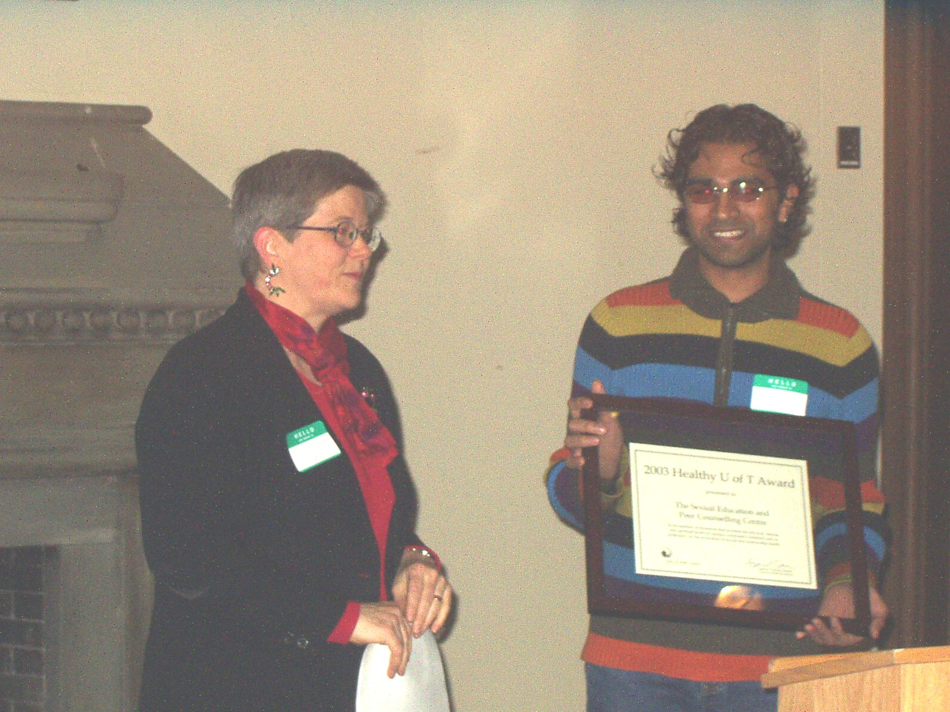  David Udayasakeran accepts the Healthy U of T Award on behalf of SEC from CHP Director, Dr. Suzanne Jackson.
The 2003 individual Healthy U of T Award recognized Dr. Luigi Girolametto, of the Department of Speech-Language Pathology. Dr. Girolametto’s nomination was a glowing testimony to the difference he has made in the health and well being of many lives, both students within his department and beyond. The letters of support that accompanied his nomination were very impressive and the lasting influence he made, and continues to make, in the lives he touches was evident. Dr. Girolametto was nominated by Speech-Pathology graduate student Janice Bennett. | 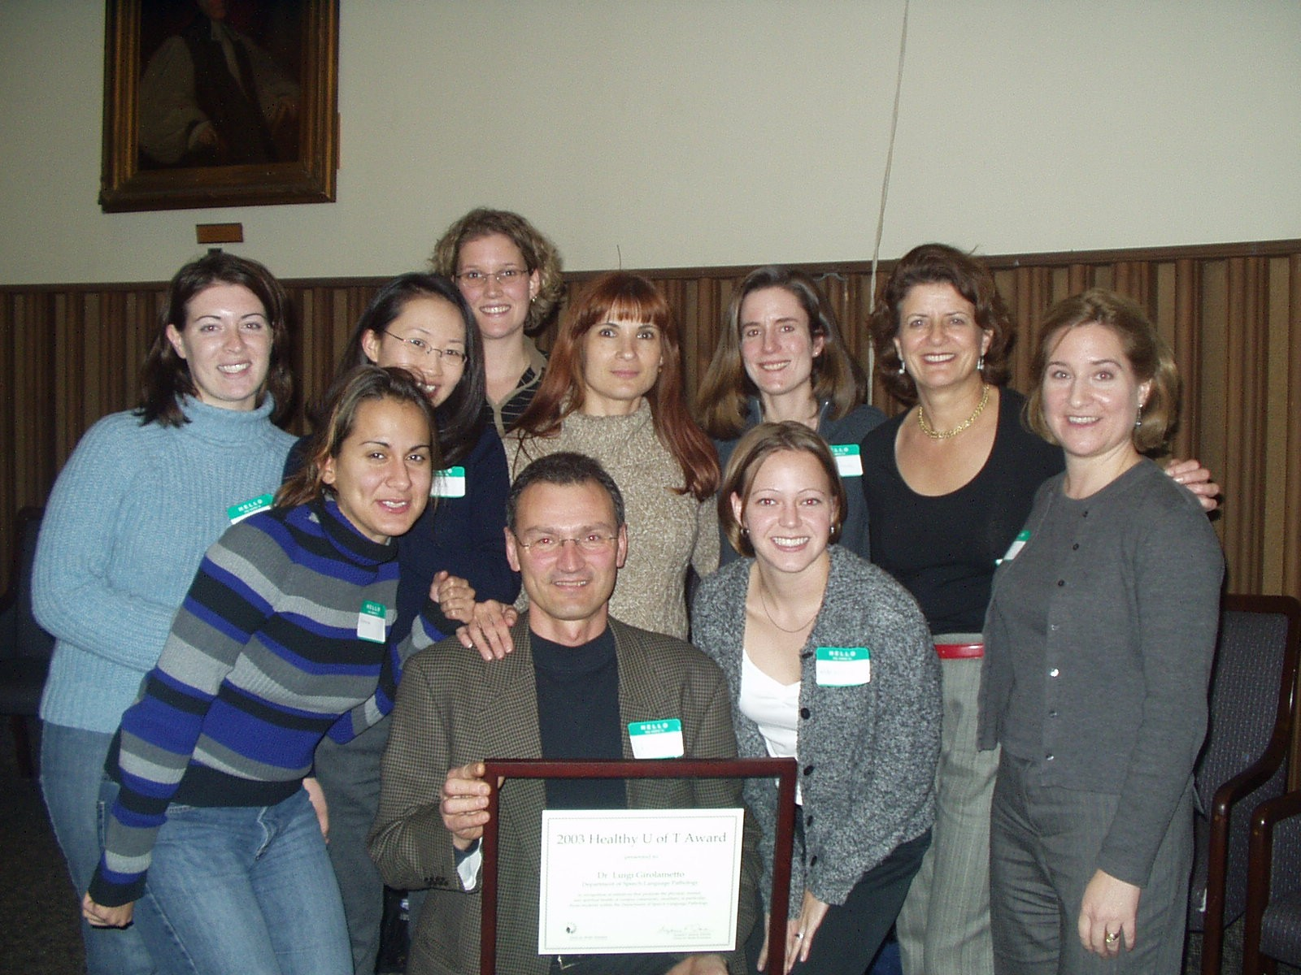  Dr. Luigi Girolametto and friends from Department of Speech-Language Pathology

Public Health Sciences Award

The Centre is also pleased to announce that one of this year’s MHSc Health Promotion practicum students, Erika Khandor, was the recipient of the James A. McNab Award, given in recognition of outstanding potential contribution to the field of health promotion. Erika is currently working out of the CHP offices on the Social Planning Network of Ontario's "Closing the Distance" initiative. The award was presented at a luncheon on Public Health Sciences day, February 27th, by  Dr. Rhonda Love of the Health Promotions Masters program. | 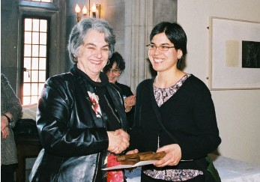  Erika Khandor receiving the James A. McNab award from Rhonda Love.

News from The Health Communication Unit (THCU)

Upcoming THCU Events

THCU is pleased to offer its series of provincial workshops for 2004. All workshops are free of charge for Ontario residents. For more information on these events, or to register online, please visit our website at http://www.thcu.ca.

Overview of Health Communication Campaigns, May 17 & 18
International Conference Centre, Ryerson University, 240 Jarvis Street, Toronto
Larry Hershfield and Nancy Dubois, The Health Communication Unit

Introduction to Health Promotion Program Planning, October 25 & 26
The Commons, Jorgenson Hall, Ryerson University, 380 Victoria Street, Toronto
Brian Hyndman and Nancy Dubois, The Health Communication Unit

Introduction to Evaluating Health Promotion Programs, November 23 & 24
The Commons, Jorgenson Hall, Ryerson University, 380 Victoria Street, Toronto
Brian Hyndman, The Health Communication Unit, and Josie d'Avernas, Program Training and Consultation Centre

THCU Discontinues Bulk Mailings

After distributing our March 2004 workshop flyer, THCU will no longer mail workshop flyers and other promotional materials in bulk. Future events, such as our February 2005 Special Topics workshop, will be promoted on our website (www.thcu.ca) and through the Ontario Health Promotion Email Bulletin (www.ohpe.ca).
However, we know that not everyone is online. If you (or someone you know) are on THCU's mailing list and do not have email or Internet access, please call us at 416-978-0522 and we will ensure that future notices will be sent on by mail.

Supporting Comprehensive Workplace Health Promotion in Ontario

The Workplace Project

The purpose of the project is to contribute to, support, and otherwise improve stroke prevention and health promotion activities that assist adults in Ontario’s workplaces to lead healthy lives, through the provision of services and materials to intermediaries. Our primary audiences are staff working with public health units and community health centres, as well as other workplace health intermediaries, such as those in the voluntary sector. The strategy is to increase the capacity of intermediaries to influence and guide those within workplaces making decisions about what stroke prevention activities and services are available to employees.

Larry Hershfield is project manager, Berkeley Butler is lead consultant; and Brian Hyndman, Nancy Dubois, and visiting consultant Lisa Sullivan make up the rest of our terrific Workplace team. We are happy to welcome Barbara Ronson as our new Conference Logistics Coordinator – she is already busy planning for our first ever Provincial Conference in Toronto (see below for details). Ali Kilbourn has also joined the THCU ranks as a part-time project assistant.

We are excited to announce our upcoming June 9th and 10th conference, “Comprehensive Workplace Health Promotion: Supporting Local Efforts in Ontario – Bringing Resources, Networks and Insights Together!” The conference will be an interactive learning experience fostering dialogue, collaboration, and innovative solutions to current workplace-health challenges.

Objectives for the conference are: to increase links and capacity among intermediaries and to supporting organizations and resources; to facilitate joint planning and resource sharing among intermediaries; to disseminate key resources; and to otherwise strengthen and sustain the regional networks.

The Conference keynote speakers include Dr. Graham Lowe, who will speak about “Strategies for Creating a Healthy Workplace,” and Dr. Julian Barling, who will discuss “A New Focus for Research – What Makes Workplaces Well?” John Perry, Senior VP at National Quality Institute (NQI) will also present a plenary session, “Training on a Small Business Awards Model.” Other highlights will include the launch of three new Info Pacs created by THCU Workplace Project, a "Neighbour @ Work" presentation by Geri McKeown and Martin Shain, and an interactive panel discussion on “What Works.”

Online registration is now available! Please see our website for more information regarding the conference or to register online: www.thcu.ca/workplace.

Also part of the Workplace Project is our new Virtual Community, now up and running at www.thcu.ca/workplace/vc! This online space gives you the opportunity to share information, resources, and experiences regarding comprehensive workplace health promotion. The Virtual Community reads much like a newspaper. It is organized into five sections: Resources, Opinions, Lessons Learned, Happenings, and the provincial workplace health promotion conference planned for June of 2004.

There is no cost involved in participating and general access (to read or view) is unrestricted, but you will be asked to register (using a login and password) in order to post stories. We invite you to enter the Virtual Community to read, write, and share your insights! We also ask that you encourage colleagues in your own networks to become a part of this new Virtual Community.

THCU Website

Visit www.thcu.ca for information on upcoming events, our consultation services, and our extensive online collection of resources on health promotion planning, evaluation, communication, policy change, and sustainability. Recent updates include new editions of our What We're Reading and Fun Finds columns.

Ontario Health Promotion Email Bulletin

The Ontario Health Promotion E-mail Bulletin (OHPE) is a weekly newsletter for people interested in health promotion produced by the Ontario Prevention Clearinghouse and The Health Communication Unit. We provide information on workshops, conferences, job postings, projects, issues and resources.

If you have not already subscribed, we invite you to visit us at www.ohpe.ca: learn about the newsletter, browse or search our complete archive of past issues, read our submission guidelines, and sign up online.

News from the International Health Promotion Unit

In our international work, the Centre has focused mostly on work in Latin America and Eastern Europe.

Latin America

As mentioned in the last newsletter, Suzanne and Lorna Heidenheim of the Ontario Healthy Communities Coalition have been working together to find funding to field test the “Participatory Evaluation Resource Manual” developed by the Pan-American Health Organization (PAHO) in three, municipalities in Ontario. The municipalities are in place, and $10,000 has been received from the Ministry of Health and Long Term Care, with PAHO agreeing to provide support at the training/orientation phase. This funding will initiate the project, and additional funding for its completion is being sought.

The project with Colombia to develop an economic evaluation guide for health promotion interventions is well underway. A first draft of the guide has been written in Spanish and CHP is working on the English version in preparation to pilot-test the guide in both Colombia and Canada.

International Union of Health Promotion and Education

Both Fran Perkins and Suzanne Jackson will be attending the International Union of Health Promotion and Education (IUHPE) conference in Melbourne, Australia at the end of April. Suzanne will be involved in two presentations – one on the economic evaluation project with Ligia de Salazar from Colombia and one with the North American Regional Office (NARO) working group on health promotion effectiveness. IUHPE has initiated a global project to look at the effectiveness of health promotion and each region is contributing. The NARO group is working on a framework and protocol to examine the effectiveness of intersectoral community interventions. Marcia Hills and Stephen Fawcett co-chair that group.

Eastern Europe

Fran Perkins has been very involved in health promotion training and support in Croatia. Suzanne sits on the Canadian Advisory Committee for a CIDA-funded Youth for Health in Ukraine project. A delegation from that project came to Toronto for a week-long study tour at the beginning of December 2003 and another group came to Toronto on April 1. These study tours are an important element of showcasing what Canada is doing in health promotion with youth.

Other

In other international work, Suzanne and Fran worked with Ian Small and others at the Centre for International Health to submit a proposal to CIDA on implementation of an immunization program in Cambodia, which includes some community engagement components. Also, Suzanne was invited by EpiBerlin to give a talk in Berlin, Germany to a group of policy-makers and epidemiologists about the difference that health promotion makes to how one conducts systematic reviews. Suzanne then gave this presentation one month later at a special workshop at Health Canada in Ottawa.

Ontario Health Promotion Summer School 2004

Committee Work and HPSS 2004 Curriculum

HPSS 2004 Planning Committees have been meeting regularly to plan a rich Summer School curriculum and social and cultural activities.

Preschool

HPSS 2004 Preschool options are more varied this year, with one introductory morning session, and two afternoon options (one for beginners: Evaluation 101, and one for more advanced students: Best Practices in Health Promotion).

Concurrent Series and Toolbox Sessions

Four Concurrent Series will be offered this year, within the two themes identified («Developing Personal Skills» and «Reorienting Health Care»). Two General Stream series will be offered, one Aboriginal Series (within Developing Personal Skills: The Medicine Wheel) and one Francophone Series (within Reorienting Health Care). Participants in Francophone series will have access once again to travel grants.

Most presentations have been confirmed. Registrants will be able to select the series of their choice, and two Toolbox sessions as they register for the Summer School.

Extra-curricular activities

The Aboriginal and Francophone committees have planned a variety of extra-curricular activities to celebrate National Aboriginal Day and La St-Jean-Baptiste Day. These will includes a Traditional Feast and performances, as well as an outing to downtown Toronto with a tour of Francophone Toronto. Yoga and Square Dancing will also be offered.

Promotion

Information has been posted on the HPSS web site at www.utoronto.ca/chp/hpss/ and registration began on March 15. Descriptions of workshops and presenters’ biographies are also available.

Printed programs have been mailed to 1000 groups and individuals on the HPSS data base. These include Francophone and Aboriginal groups and institutions throughout the province.

A special ad was posted in the Aboriginal newspaper, Tansi! and will run again before May.

Accreditation

Certificate of Completion

Graduate credits may be an option (Certificate of Completion), should enough participants request this option. This will be offered by the Faculty of Medicine Continuing Education Department. Due to criteria established by the University of Toronto, participants cannot acquire their half-credit at HPSS 2004, because there are not enough ‘instructional hours’ offered during the week. Those interested in acquiring this half-credit would have to attend an additional program that would entail additional instructional hours (to complete the required number: 39). This option will be determined based on interest expressed.

Physician’s Credits

The Centre for Health Promotion’s Ontario Health Promotion Summer School (HPSS) is now accredited by the Royal College of Physician and Surgeons and has received recognition from the University of Toronto’s Faculty of Medicine Continuing Education Department. This is available to all physicians who request it.

Update on the Centre’s Special Projects

National Literacy and Health Project

Currently, the National Literacy and Health Project is undertaking a retrospective evaluation of the National Literacy and Health Program. The evaluation will be completed by the end of June and the findings will be presented at the Second National Literacy and Health Conference in October. I have also been involved in the planning of this Conference which will be sponsored by the Canadian Public Health Association and would encourage researchers and practitioners associated with the Centre to submit abstracts. The URL is: www.cpha.ca/literacyandhealth

-- Irv Rootman, Project Coordinator

MHSc Student Practicums in Health Promotion

From January to the end of April 2004, seven MHSc students from the Health Promotion program at the University of Toronto have been hard at work on their practicum project.

Salima Allibhai is working with the Family Wellness Centre at the Scarborough Hospital, Grace Division. Salima is conducting a program review designed to examine the relevancy and effectiveness of the Family Wellness Centre's programs and strategies. The findings and recommendations from Salima’s study will be given to the Family Wellness Centre Advisory Committee and the Hospital's Board of Directors for review.

Niki Deller is developing peer support strategies in the area of maternal, new born and family health. Niki’s project is a joint venture with the Self-Help Resource Centre and the Best Start Resource Centre.

Maria Grant is on placement at Health Canada’s Population and Public Health Branch Ontario & Nunavut Region where she is carrying out a descriptive project on public health in Ontario. The project involves identifying the key players in public health, describing their roles, and reporting on their relationships or interactions with others in the field, with the goal of bringing about a better understanding of the diverse nature of public health in Ontario for regional staff. Maria has conducted key informant interviews with individuals in the public health arena, asking questions about the issues and challenges that organizations face, their roles in the public health community, and their thoughts on the future of public health in Ontario.
Erika Khandor is working with the Social Planning Network of Ontario's "Closing the Distance" initiative, a group of five local projects led by social planning councils across Ontario working on Social and Economic Inclusion. She is collecting and analyzing information about the diverse experiences local communities had in working towards Social and Economic Inclusion in the communities of Kingston, Peel and Halton, Central West Region (Kitchener-Waterloo, Cambridge & North Dumfries and Brant County), Sudbury and Thunder Bay. The experiences of these projects will then be written into case studies in an accessible story format, for use by local groups working in the area of social inclusion and community development.

Jaime Pachis is studying the ways in which the components of early parenting programs operating in Toronto influence the breastfeeding outcomes of mothers enrolled in the programs. In addition, she is working with the Centre, conducting an evaluation of an early parenting program at its eight different sites across North Toronto.

Teresa Petch is examining issues related to the computerization of the health care sector at the Centre for Clinical Epidemiology and Evaluation, Vancouver General Hospital, as part of a research team, led by Dr. Ellen Balka,. Specifically, Teresa is designing a research tool to systematically analyze and compare the content of health information web sites. To complement the data extracted from the web sites, Teresa will conduct key informant interviews with professionals associated with each web site reviewed in order to gain a deeper understanding of how the individual web sites are established, developed and maintained.

Tara Johnston is working with East York/East Toronto Family Resources to develop, coordinate and facilitate a needs assessment for the development and/or adaptation of Ontario Early Years Centre programs. Tara’s project is directed at young parents who traditionally do not access the services available within the Toronto Centre Rosedale riding.

Join the Centre for Health Promotion

The Centre has gone through a number of changes over the past two years and we are continuing to evolve. To do this effectively, we need your input.

We are planning a meeting of interested participants on May 14, 2004 from 2:00 to 4:30 p.m. to discuss the Centre’s future direction and how you, and others, can play an active role in this future. Please indicate your interest in attending by emailing the Centre’s Administrative Assistant, Nora Sellers, at nora.sellers@utoronto.ca. Nora will then be in touch about the meeting location.

In the meantime, below is a proposed draft of the new criteria for membership in the Centre for Health Promotion. These criteria will be one agenda item for discussion at the proposed May meeting. Emailed comments on the following, sent to Nora at the email address above, are also welcome if you are unavailable to join us in May.
Centre for Health Promotion Membership Terms

Fellows

A Fellow of the Centre for Health Promotion (CHP) is someone who conducts all or part of their work under the auspices of the Centre. Their name is directly associated with funding and projects run through the Centre. Fellows are contributors to the field of health promotion, have recognized expertise in health promotion, and follow the basic principles and mission of health promotion at CHP. The Fellows of the Centre are offered the following:

Use of space (telephone, computer, desk, internet connection) when working on specific CHP projects, if desired;
Financial management of the project grant or contract;
Connection to international and other projects;
Ethics reviews, if necessary;
Use of CHP name for proposals and grants;
Exposure of the project and its products on CHP website;
Access to Masters level University of Toronto health promotion students for practicums.

In return, the Centre for Health Promotion expects the following from Fellows:

Contribution of volunteer time to the Centre (at least 5% or 1 day per month). Volunteer activities include, for example:
attendance at some CHP meetings and input into CHP affairs on request;
support for study tours, visiting scholars, and students working at CHP;
support for special projects at the request of the Director;
Management of at least one project per year run through the Centre and which contributes financially to CHP administration.

You become a Fellow by direct invitation of the Director, who will specify the timeframe of the offer.

Current Fellows and Senior Fellows: Richard Edwards, Michael Goodstadt, Larry Hershfield, Brian Hyndman, Fran Perkins, Barbara Ronson, Reg Warren, Rick Wilson

Members

A Member of the Centre for Health Promotion is a volunteer who contributes some time, energy, and expertise to CHP health promotion projects and initiatives.

The Centre offers its Members:
Newsletters twice a year and an invitation to the AGM;
The opportunity to participate in a Centre Interest Group or Committee (e.g. Healthy Schools, Cancer Prevention, Summer School Planning Committee);
Information about major events (via email);
Invitations to participate in special “Friends” events;
Opportunity to volunteer or work on certain CHP projects.

In return, the Centre expects its Members to:
Contribute to the Centre through volunteer activities, including:
join an existing Interest Group or initiate the formation of a new group
be available as a potential speaker in your area of expertise
help in planning the Health Promotion Summer School or volunteer at the event
Maintain a strong interest in the Centre’s activities and in promoting the work of the CHP.

DRAFT

Centre-E-Info-Update
Centre for Health Promotion
University of Toronto
100 College Street, Suite 207
Toronto, ON M5G 1L5
www.utoronto.ca/chp

